**Vision Statement**

A community of curious and responsible individuals, aspiring to grow and serve.

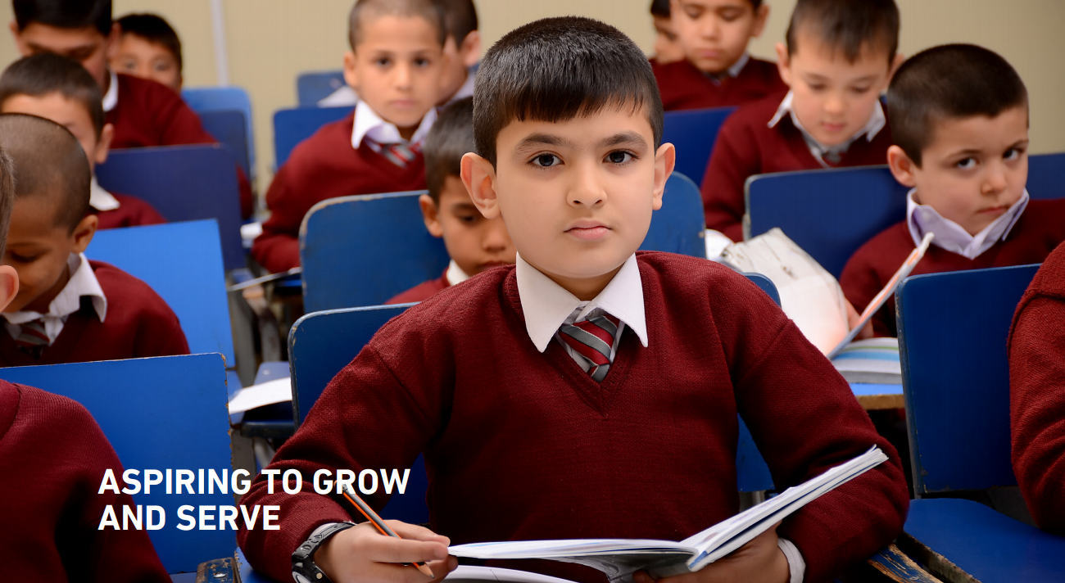

**Mission Statement**

A community of curious and responsible individuals, aspiring to grow and serve.

To this end, Kardan is setting high expectations by aligning instructional practices to international standards and hiring qualified educators who will deliver the innovative curriculum that promotes 21st century learning skills.

**School Strategic Improvement Plan (SIP)**

The School Improvement Plan (SIP) is a live document that is updated and revised while working on the Self-Evaluation Form (SEF) for each school. It is developed based on the schools’ key priorities for the next 3 academic years. The schools’ Senior Leadership Teams reflect on the actions and strategies to check the impact on the students’ achievement.

**Priorities**

* Implement Effective Academic Processes, Policies, Procedures, and Forms
* Implement Action and Succession Planning
* Disseminate Outstanding Teaching Practices across the Schools
* Build Staff Capacity
* Improve Student Progress and Attainment
* Focus on Literacy
* Enhance Student Character and Personal Development
* Develop Collaborative Relationships with Parents and the Community
* Improve Provisions for Student Health and Safety

**Priority 1: Implement Effective Academic Processes, Policies, Procedures, and Forms**



















**Priority 2: Implement Action and Succession Planning**













**Priority 3: Disseminate Outstanding Teaching Practices across the Schools**











**Priority 4: Build Staff Capacity**



**Priority 5: Improve Student Progress and Attainment**



**Priority 6: Focus on Literacy**



**Priority 7: Enhance Student Character and Personal Development**



**Priority 8: Develop Collaborative Relationships with Parents and the Community**



**Priority 9: Improve Provisions for Student Health and Safety**















